1. Manage Role-Based Access Control (RBAC)
Role-Based Access Control (RBAC) is used to manage access to Azure resources. It allows assigning specific roles to users, groups, or applications to control their permissions on resources.
Steps to Create and Manage RBAC:
- Assigning Roles to Users or Groups:
  - Navigate to the Azure portal > Azure Active Directory > Roles and administrators.
  - Select the role you want to assign (e.g., Owner, Contributor, Reader).
  - Click on Add Assignment, then select the user or group.
  - Review and assign the role.
- Creating Custom Roles:
  - In the Azure portal, go to Azure AD > Roles and Administrators > + New custom role.
  - Define the role permissions by either selecting built-in role definitions or defining custom permissions.
  - Assign this role to users or groups as needed.
- Scope of RBAC:
  - Roles can be assigned at various levels of the Azure hierarchy: subscription, resource group, or individual resource.
  - The higher the level (subscription), the more broad the permissions are.
2. Assisted Practice: Creation of Management Groups
Management Groups are used to organize Azure subscriptions, providing a governance layer for large organizations.
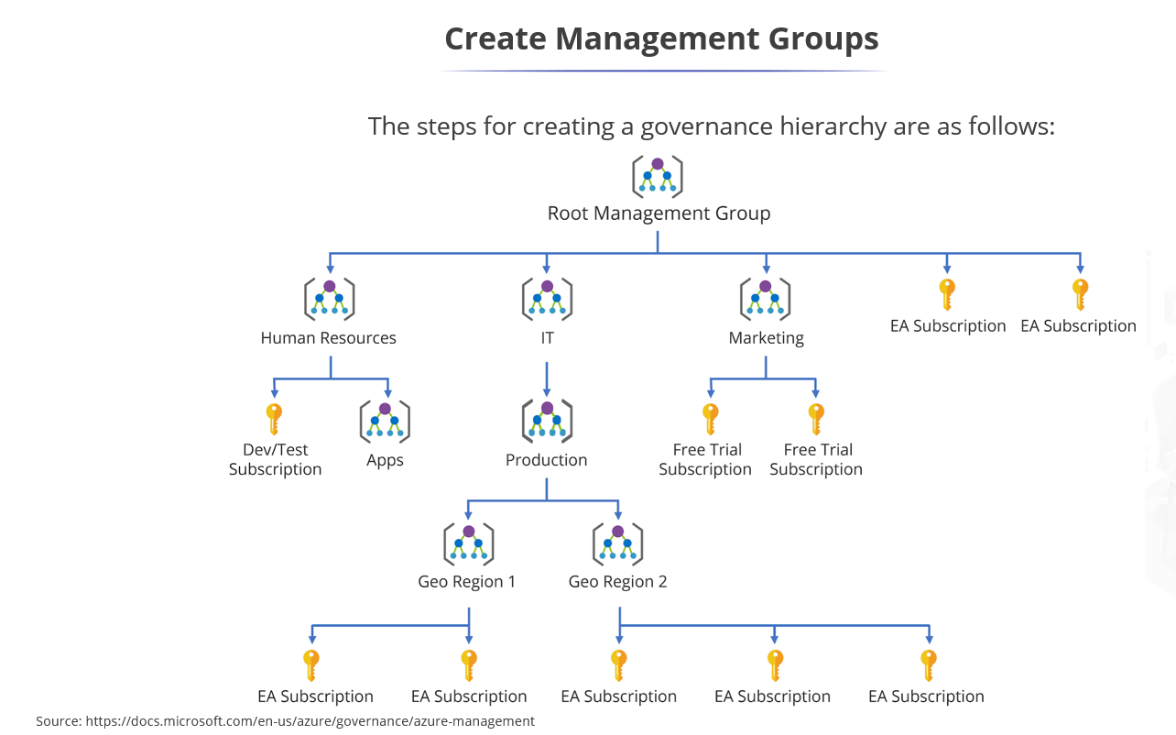
Steps to Create Management Groups:
- Navigate to the Azure portal > All services > Management Groups.
- Click on + Add management group.
- Enter a Management Group ID (this should be unique).
- Optionally, provide a Display Name.
- Click Save.
- Now, you can assign subscriptions to management groups to enforce policies and RBAC roles at a broader level.
3. Assisted Practice: Implementing an Azure Policy
Azure Policy is a governance tool that helps you manage resources by enforcing rules and policies across your resources.
Steps to Implement an Azure Policy:
- Navigate to Azure Policy in the Azure portal.
- In the Definitions section, click + Policy definition to create a custom policy.
- Define the policy rule in JSON format.
- Once defined, assign the policy to a scope (subscription or resource group).
  - Assign Policy: Choose the scope, and select the policy definition to apply it.
- You can assign policies to manage resource configurations, ensure compliance, and restrict certain actions.
4. Assisted Practice: Create Resource Locks
Resource Locks prevent accidental deletion or modification of Azure resources.
Steps to Create Resource Locks:
- Navigate to the resource (e.g., VM, Storage Account) in the Azure portal.
- In the Settings section, click Locks.
- Click + Add to create a new lock.
- Choose a Lock type:
  - CanNotDelete: Prevents deletion.
  - ReadOnly: Prevents modifications.
- Assign a Lock name and click OK.
5. Administer Identity
Azure Active Directory (Azure AD)/Microsoft Entra ID is the identity management service for Azure. You can use it to administer users, groups, roles, and more.
6. Assisted Practice: Implement Self-Service Password Reset (SSPR)
Self-Service Password Reset (SSPR) allows users to reset their passwords without contacting the help desk.
Steps to Enable SSPR
- Sign in: Go to the Microsoft Entra admin center and sign in as an Authentication Policy Administrator or Global Administrator.
- Locate SSPR: Browse to Protection > Password reset.
- Enable SSPR:
  - On the Properties page, set Self service password reset enabled to Selected (for a specific group) or All.
  - Select the group (e.g., a group with P2 licenses) if "Selected" was chosen, then click Save.
- Configure Authentication Methods:
  - Click Authentication methods and set the number of methods required (e.g., two).
  - Select allowed methods such as Email, Mobile app notification, or Mobile phone.
- Configure Registration:
  - Go to Registration and set Require users to register when signing in to Yes.
  - Set the number of days before users must reconfirm authentication info (default is 180 days).
- Optional - Configure Notifications: Set notifications to notify users or administrators when a password reset occurs.
User Registration
Users can register for SSPR by navigating to https://aka.ms/ssprsetup or via the "Register for password reset" link in their access panel.
Hybrid Environment Setup (Password Writeback)
If you have on-premises Active Directory, you must enable Password writeback through the Microsoft Entra Connect wizard to synchronize password changes back to your local environment.
Licensing Requirements
- Entra ID Free: SSPR is available only for cloud users.
- Entra ID Premium P1 or P2: Required for hybrid users (on-premises) and advanced features like custom branding and stricter policies.

7. Assisted Practice: Create Users and Group Accounts
Creating users and groups in Azure AD allows you to manage access to resources.
Steps to Create Users:
- Navigate to Azure AD > Users > + New user.
- Choose whether you are creating a New user or Invite external user.
- Fill in the user details (e.g., Username, Name, Profile Information).
- Assign roles and licenses if required.
- Click Create.
Steps to Create Groups:
- Navigate to Azure AD > Groups > + New group.
- Choose the Group type (Security or Microsoft 365).
- Enter a Group name and Group description.
- Assign users to the group by selecting them from the list.
- Click Create.
8. Assisted Practice: Insert Guest Users to Directory
You can invite guest users (e.g., external contractors) to your Azure AD directory.
Steps to Add Guest Users:
- Navigate to Azure AD > Users > + New guest user.
- Choose Invite user.
- Enter the guest user’s email address and any other required information.
- Optionally, assign them to a group or role.
- Click Invite. The user will receive an invitation to join your directory.
9. Knowledge Check
After completing these tasks, it is useful to go through a Knowledge Check to assess your understanding. You can review the topics covered by testing your knowledge with questions like:
- What is the scope of an RBAC role?
- How does Azure Policy help enforce governance?
- What is the difference between CanNotDelete and ReadOnly locks?
- How do you configure self-service password reset in Azure AD?
10. Lesson End Project: Implementing Azure Active Directory
For the final project, you will need to demonstrate proficiency in managing Azure Active Directory services.
Steps to Complete the Project:
- Implement RBAC:
  - Assign appropriate roles to users and groups at the resource, resource group, or subscription level.
- Configure Azure Policy:
  - Implement policies to enforce organizational compliance.
- Set up Resource Locks:
  - Lock critical resources to prevent accidental deletion or changes.
- Enable Self-Service Password Reset:
  - Ensure users can reset their own passwords using Azure AD’s SSPR feature.
- Create and Manage Users/Groups:
  - Add internal and external users, and organize them into groups based on roles.
- Test:
  - Verify each service works as expected and users can access resources appropriately.

